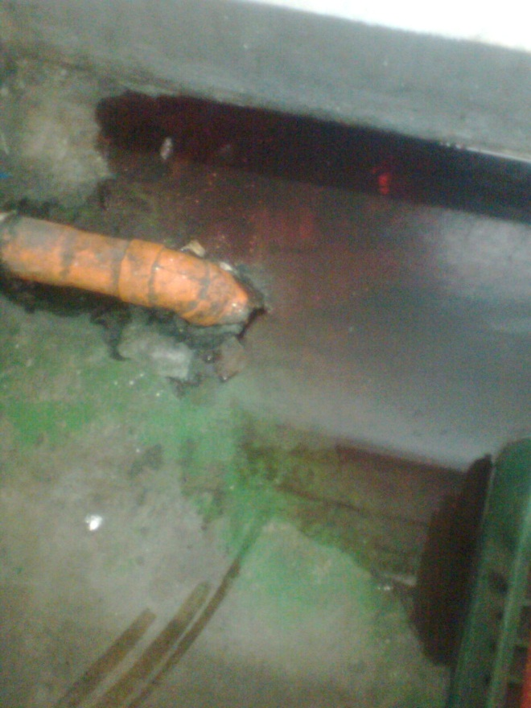 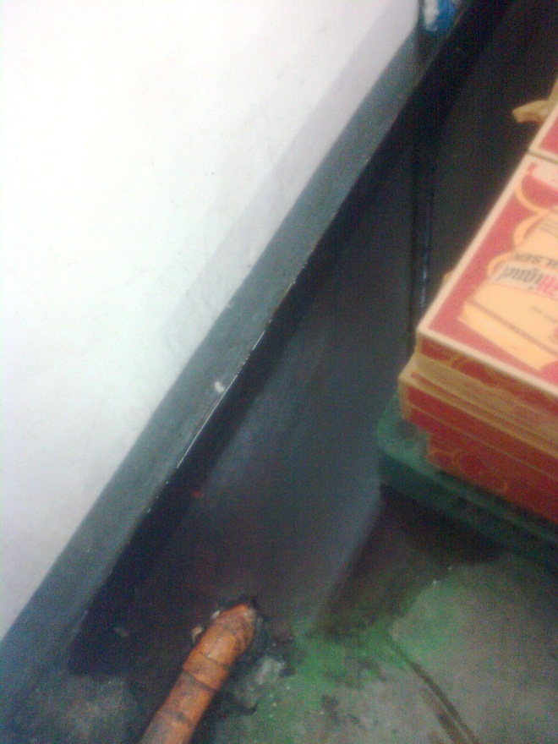

**BONDED PREP. (DRINKS/WINE/LIQUORS AREA)**